Warning – Approaching Vehicle Audible System – CGEA1.3

Functional Description

The purpose of the Approaching Vehicle Audible system (AVAS) warning contained within this STSS is to inform the driver that the pedestrian sounder has failed and the vehicle needs to be taken in for service.

Due to quiet operation on Electric Vehicles (EV), Hybrid Electric Vehicles (HEV) and Plug-in Hybrid Electric Vehicle (PHEV) at low vehicle speeds, there exists a higher risk of vehicle/pedestrians collisions. The purpose of the AVAS is to have the function of a ‘vehicle sounder’ to create pleasing noise (similar to an internal combustion engine) to alert pedestrians of the presence of EV, HEV or PHEV vehicles when they are nearby. The sounder will operate when the vehicle is operational (meaning with an engaged ignition, in a state of being functional even though it may not be moving), moving at speeds greater than or equal to zero kilometers per hour(>=0 kph) and lesser than or equal to thirty kilometer per hour (<=30 kph); in forward or in reverse direction. The Pressure Level and frequency will vary depending on vehicle direction and vehicle speed as FMVSS 141 states.

The Approach Detection warning function correlates the PdstrnAlrt_B_Falt signal from the Pedestrian Alert Control Module (PACM) and Operational_Mode to either activate or deactivate the warning message on the cluster display.

This STSS replaces the previously released “Warning – Approach Detection – CGEA1.3” due to confusion regarding the EOL configuration bit defined in it. That spec has a configuration bit named “Approach Detection”, which conflicts with the “Approach Detection Control System – CGEA1.3” STSS. However, these two are completely different functions/features in the vehicle and thus have separate configuration parameters. This STSS defines a new configuration parameter for the AVAS warning. All programs should use this STSS for the AVAS/Pedestrian warning.

Interfaces

Interface Context Diagram (I/O Block Diagram)
Figure 1: Approaching Vehicle Audible System Warning Context Diagram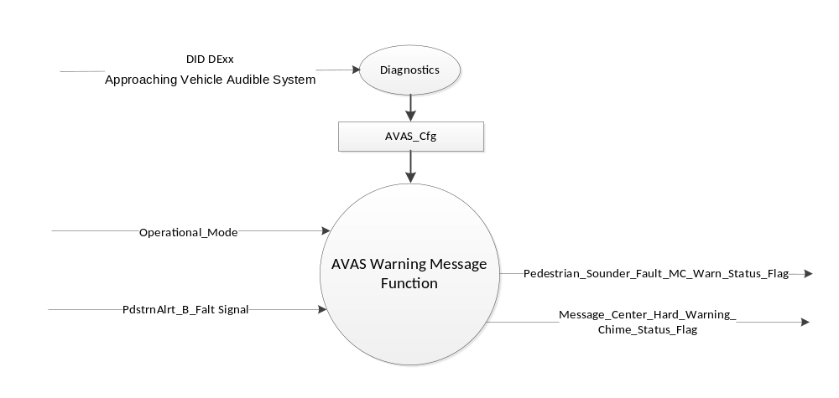

Inputs

      - INTERNAL:
            - AVAS_Cfg
            - Operational_Mode

      - MUX signal on CAN

- PdstrnAlrt_B_Falt Signal
Signal Name | Size  (bits) | Detail | Units | State Encoded | Min. | Max.
PdstrnAlrt_B_Falt | 1 |  | SED |  | 0 (0x0) | 1 (0x1)
 |  | No |  | 0x0
 |  | Yes |  | 0x1

Outputs
      - Pedestrian_Sounder_Fault_MC_Warn_Status_Flag, which is used to control the state of the warning message.
      - Message_Center_Hard_Warning_Chime_Status_Flag

Function/Performance

Operational Modes

Mode | Operational Mode
Sleep Mode | Approaching Vehicle Audible System Warning Inactive
Limited Mode | Approaching Vehicle Audible System Warning Inactive
Normal Mode | Approaching Vehicle Audible System Active / Inactive
Crank Mode | Approaching Vehicle Audible System Active / Inactive

Voltage Levels

Refer to the Cluster Features table located in the Operational Modes and Voltage Range Strategies section in this SPSS.

Human-Machine Interface

Visual

Indicator Graphics / Display Format

Message Center Text Warning Messages as defined in section Table 1.2 of this document.

Indicator Color Coordinates

Reference section COLOR & ILLUMINATION REQUIREMENTS (GRAPHICS).

Audio

As per table 1.2 and Refer to Audio Section in Chimes & Chime Arbitrator SPSS Section.

Switch Control Logic

None.

System Accuracy

Within 100 msec of receiving a message that results in a change of state the cluster will update the output flag to the proper state.

Operation: Performance and Functional

Subsystem Algorithm Flowchart / State Diagram

Figure 2: Approaching Vehicle Audible System Diagnostic Routine Diagram
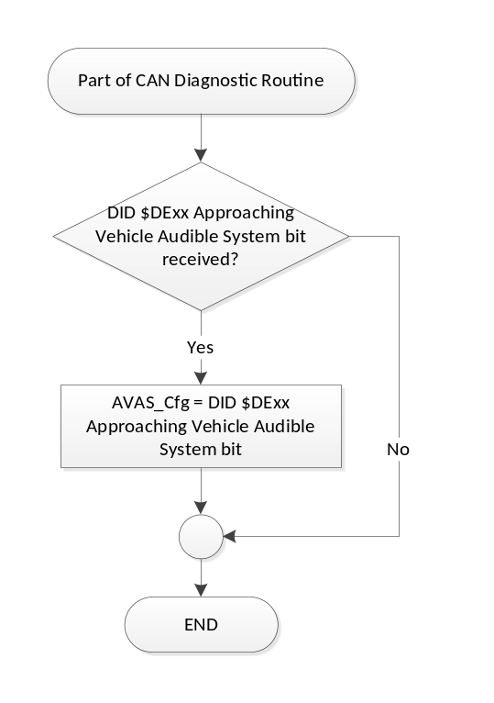
- State Matrix for Pedestrian Sounder Fault MC Status Flag
AVAS_Cfg | Operational_  Mode | PdstrnAlrt_B_Falt Signal | Pedestrian_Sounder_Fault_  MC_Warn_Status_Flag
Enabled  (0x1) | Normal or Crank | Yes (0x1) | Active
Enabled  (0x1) | Normal | Declared Missing as per 1.4.1 | Active
All Other Cases |  |  | Inactive

- Pedestrian Sounder Flag MC Status Flag to MC Message IDs
MC Status Flag | Mc Warning Message ID | Active Chime_Chime_Status_Flag
Pedestrian_Sounder_Fault_MC_Warn_Status_Flag | W3435 | Message_Center_Hard_Warning_  Chime_Status_Flag

Operation Description (supports algorithm flowchart /state diagram)

- For definition of how the Message Center arbitrates and displays Active warnings, see the Warning / Alert Display Logic Diagram, located in the Message Center – X Display with W Button Interface section of this SPSS (where X and W are appropriate values in this document).

- The warning shall only be activated when AVAS_Cfg is set to “Enabled” (0x1).

Function Safety Classification (EMC)

Class B

Memory Storage
Parameter Name | Description | Value at  Battery Connect | Value at  Module Wake-up
Pedestrian_Sounder_Fault_MC_Warn_Status_Flag | Output display status flag used to activate warning. | Inactive | Inactive
PdstrnAlrt_B_Falt Signal | CAN signal sent from the PACM module. | No (0x0) | No (0x0)
AVAS_Cfg | State Indicator for feature presence controlled via CAN at EOL at VO plant. Defaulted to DISABLED at supplier manufacturing. | Use Stored Value | Use Stored Value
Operational_Mode | 4 state indicator for cluster operational mode. | Limited | Limited, Normal or Crank
Message_Center_Hard_Warning_Chime_Status_Flag | Used to control the state of the chime to the Chime Arbitrator | Inactive | Inactive

Prove Out

None.

Reconfigurable Telltale

None

Message Center Message

See Section 1.3.5.1 for state tables and Table 1.2 for Warning Message ID #s.

Error Handling

Missing Message Strategy

The signals will be declared missing as per the Diagnostics section of this SPSS.

DTCs states and history will be determined as per the Diagnostics section of this SPSS.

If AVAS_Cfg = 0x0 (Disabled), the cluster shall never log a missing message DTC due to this feature.

Diagnostics

Self Test

None.

Engineering Test Mode

None.

Part II Performance

DID $DExx
Block  Num | Block Description | Size (bits) | Byte(s) | Bit(s) | State: Description | "0" | "1" | Default | Comments/  Information
PACKETED BLOCKS
$xx | Option Content (B&A) | 1 | * | * | Approaching Vehicle Audible System | Disabled | Enabled | Disabled | Disabled means the feature is not present in the vehicle.
 | *Byte and bit location to be identified in Part II Specification for this cluster.

Supported Diagnostic Trouble Codes (DTCs)

DTCs shall be logged as per the diagnostics section of this SPSS.*

DTC | Description
C13F00 | Lost Communication With Pedestrian Alert Control Module

Reference Specifications

IS-0001 WARNINGS/INDICATORS/DISPLAYS PROVEOUT
IS-0046 INSTRUMENTATION MATERIAL RESISTANCE TO CLEANING
IS-0052 OPERATING VOLTAGES - FUNCTIONAL/PERFORMANCE
IS-0069 FUNCTIONAL IMPORTANCE CLASS
IS-0324 WINDSHIELD & OTHER REFLECTIONS
IS-0327 WARNING INDICATOR EVALUATION
IS-0379 NORTH AMERICAN WARNINGS AND INDICATORS STRATEGY

IL-0021 CRAFTSMANSHIP - DISPLAYS
IL-0023 CLARITY/LEGIBILITY/READABILITY
IL-0025 INTERIOR ILLUMINATION INTENSITY
IL-0027 VISUAL CONTRAST
IL-0043 OPERATIONAL ENVIRONMENT FUNCTIONALITY
IL-0045 COLOR
IL-0048 ILLUMINATION ACCEPTABILITY

03-0661 PLACEMENT: CONTROL AND DISPLAY LOCATIONS
03-0662 PLACEMENT: LOGICAL GROUPING FUNCTION AND USAGE
03-0664 PLACEMENT: DOWN VISION TO COMPONENTS WITH HIGH VISUAL DEMAND
03-0665 PLACEMENT: EXPECTED LOCATIONS OF CONTROLS AND DISPLAYS VDS
03-0670 INTERIOR VISIBILITY
03-0671 INTERIOR VISIBILITY: REFLECTIONS FROM COMPONENTS & SURFACES
03-0672 INTERIOR VISIBILITY: REFLECTIONS IN DISPLAYS
03-0673 INTERIOR VISIBILITY: VISUAL OBSCURATIONS
03-0674 INTERIOR VISIBILITY: ILLUMINATION CONTROLS / DISPLAYS
03-0675 INTERIOR VISIBILITY: VEILING GLARE
03-0677 INTERIOR VISIBILITY: SUNLIGHT WASHOUT
03-0681 IDENTIFICATION: CHARACTER AND SYMBOL SIZE
03-0682 IDENTIFICATION: LEGIBILITY
03-0685 IDENTIFICATION: SYMBOLS, ABBREV FOR CONTROL
03-0721 LOGIC OF OPERATION: OPERATIONAL STEREOTYPES
03-0722 LOGIC OF OPERATION: INTERPRETATION
03-0723 LOGIC OF OPERATION: USE OF SYSTEMS WITH VISUAL DISPLAYS

Revision History

STSS Module Revision History

Revision Level | Name | Change Description | Date
1.0 | V. Patel | Initial revision. This STSS replaces the previously released “Warning – Approach Detection – CGEA1.3” STSS.  (Feature owners: Mendoza, Ruben, Martinez Carranza, Dynora) | 11/24/2015
1.1 | Ilopezla | This Update is to inform which Chime Status Flag is associated with this warning as per Global_Msg_List_ver32_Released_6_24_2015 (all changes are highlighted in light blue)  Section 1.2.1- Figure 1-Added  Message_Center_Hard_Warning_Chime_Status_Flag  Section 1.2.3 Added- Message_Center_Hard_Warning_Chime_Status_Flag  Section 1.3.5- Updated Table 1.2 –  Changed column’s name from “Chime” to “Active Chime_Status_Flag”  Replaced “Per Global Message list “to “Message_Center_Hard_Warning_Chime_Status_Flag”  Section 1.3.5.4-Added  Message_Center_Hard_Warning_Chime_Status_Flag  To Memory Storage Table | 1/11/2016

